* Purpose :- Safe erection and dismantling of scaffolding
* Scope : - Structural, piping, repair & painting jobs at height
* Responsibility : - Engineer In charge & Maintenance Fitter on job

PPE –s to be used :

Helmet, Safety shoes, Hand gloves, Dust mask, full body harness and safety goggle

Aspect Impact

|  |  |
| --- | --- |
| Scrap generation | Resource Depletion |

**HAZARDS**

**Mechanical Hazard**

1. Fall of person from height
2. Collapsing of scaffolding
3. Slipping of person
4. Drowning of person while working in cooling tower cell / thickener/Pontoon
5. Access to fire alarms, cable tunnels, hydrants, etc, shall remain free at all times.
6. Care shall be taken that no part of scaffolding is struck by a truck or other heavy moving equipment and no material shall be dumped against it.

**Chemical Hazard -**

1. Inhalation of Toxic chemicals.
2. CO gas poisoning while erecting / dismantling scaffolding near gas line.
3. Fire & Explosion while working in poorly ventilated area.

**Physical Hazard –**

1. Fall of objects in eyes
2. Hitting of protruding object.
3. Falling of scaffolding material on person
4. Impact by truck, moving machinery
5. Storm, rainfall

**Electric hazard**

1. Electrocution due to scaffolding pipe/material in contact with HT/LT power line.
2. Electric shock of equipment
3. Fire due to electrical short circuit
4. Electrocution of person coming in contact with live wire.
5. All portable electric equipment used on the scaffold must be protected.

**Human Behavioral hazards**

1. Casual approach of person
2. Horse play
3. working under the influence of alcohol
4. Not using PPE’s.
5. Climbing Scaffold while carrying material in one hand (always to have 3-point contact while climbing on scaffold)

**Special Note: This procedure is to be read in conjunction with SP44, SP46 painting and working at height.**

**Scaffolding** is widely used during construction and renovation activities. In its simplest form, a scaffold is any temporary elevated or suspended work surface used to support workers and materials. There are many types of scaffolds, like supported and suspended. Here we are Discussing about general requirements for all scaffolds

**Indian Standard applicable: IS:3696 (Part 1) - 1987**

**General safety requirements**

1. Scaffolds shall be provided for all work that cannot be safely performed from the ground, or from solid construction.
2. The footing of scaffolding must be sound and rigid, capable of supporting the weight. Scaffolding must not be placed on unstable objects, Un even Surfaces such as bricks, blocks, Clay, Sand and barrels.
3. Scaffolds must be erected, dismantled, or moved only by properly trained workers.
4. Scaffolds and its components must be able to support at least four times the intended load.
5. Standard guardrails (e.g., handrail and midrail) and toe boards must be provided for all open sides of the scaffolding that are ten (10) feet or more above the surrounding surfaces.
6. To protect against falling objects, screens must be installed between the toe board and midrail if material is to be stored on work platform.
7. Any damaged or weakened component of a scaffold must be repaired or replaced immediately.
8. All decking shall be close-boarded, each board resting evenly on at least three supports. Boards shall over sail end supports by at least 2" (50 mm) but shall not over sail by more than four times their thickness.
9. Every platform, gangway, run or stairway shall be kept free from any unnecessary obstruction, material, rubbish and projecting rails, whenever they become slippery, appropriate steps shall be taken by way of sanding, cleaning or otherwise to remedy the effect.
10. An access ladder or other safe access must be provided.

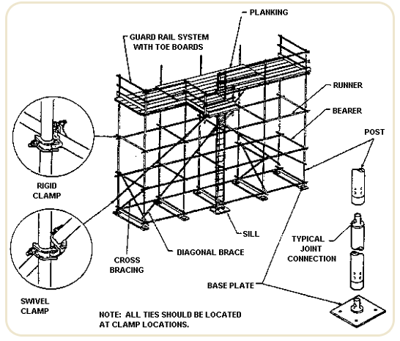

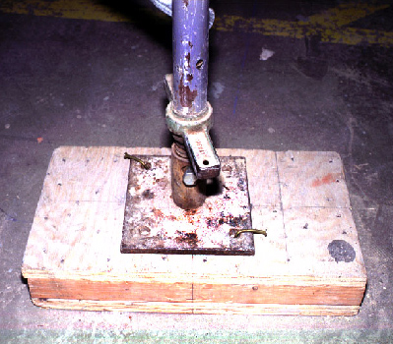

**Scaffolding during painting and structural works**

1. Take work permit from production department from shift Superintendent / Engineer in charge if the work is related to production after following all the related safety indicated in the work instruction.
2. If the job is near gas-affected area take CO monitor and confirm CO concentration is below 35 ppm.
3. Electrical shutdown of overhead HT/LT lines are required if scaffolding is to be carried out in its vicinity of 6 meters.
4. Cordon the area coming under scaffolding.
5. If the painting/structural job is to be carried out at height above 2 meters proper scaffolding arrangement needs to be made. (strictly no bamboo scaffolding )
6. The preferred system of scaffold is modular (H Frame), and tube and coupler. The use of all other scaffolds must be subject to a detailed risk assessment and must be approved by site leader.
7. Ensure that the scaffolding material is inspected as per the checklist given in SP44 G
8. Scaffolding should be made with 40NB GI pipes with 48.3 mm nominal outside diameter. Scaffolding pipes and planks to be lifted at height using manila rope. Gin wheel can be used to reduce the effort.
9. No person should stand below pipes/planks being lifted or placed at height.
10. Person climbing on top to do scaffolding arrangement must wear full body harness with dual lanyards and all PPE required for working at height.
11. Assembly/joining of scaffolding pipes to be done with metallic couplers confirming to BS 1139, EN 74 or Vedanta approved equivalent standard.
12. Each supporting member for scaffolding, stair, and runway shall be placed on firm, rigid smooth foundation that prevents lateral displacement
13. At every stage after erection it has to be braced properly to avoid collapsing and guard railing to be fixed.
14. Make sure that pipes used for scaffolding are not protruding in workable area of other workmen or not in dangerous position to hit someone.
15. Where possible the scaffolders must:
    1. erect the scaffold at 1 metre increments;
    2. maintain no less than two planks wide; and
    3. provide edge protection at each level where there is the potential to fall to a lower level.
16. When installing or erecting scaffolds over or beside water, risk controls may include alternative erection methods, for example prefabrication away from the water and installation by crane.
17. Site Supervisor should ensure that scaffolding is marked with appropriate tags (Green, Red etc.) Access to red tagged scaffolding to be blocked to ensure no unauthorised person uses the scaffolding under erection or dismantling.
18. Once the scaffolding is ready, site supervisor should inspect the scaffolding as per the checklist provided in SP44 G and mark the scaffolding with green tag.
19. Scaffolding shall be re-inspected at least every seven days or after modification/alteration and after adverse weather phenomenon which is likely to have affected stability, whichever occurs earlier.

**DO’S**

* Barricade the area below and in the vicinity of scaffolding
* Take electrical shutdown of HT/LT lines if scaffolding is to be carried out in its vicinity of 6 meters.
* Carry 2 CO monitors if job is carried out in gas prone area, confirm gas concentration to be very negligible.
* Use 40NB GI pipes only
* Inspect the scaffold material before erection
* Use metal couplers for securing the scaffolding
* Make sure that scaffold pipes are not protruding in workable area
* Wear full body harness with dual lanyards for working on scaffold above 2 mtr height

**DONT’S**

* Use bamboos for scaffolding
* Stand below pipes, planks, etc being lifted at height
* Throw material from height

## SAFETY IN SCAFFOLDING

### Fall prevention

#### 2.1.1 General approach

During the scaffolding process, scaffolders will normally be faced with a potential fall from height hazard. It is essential that all practicable steps are taken to control this hazard and that the hierarchy of control is applied to the hazard management process.

**Safety harnesses must be worn at all times when working on all scaffolds above 2.0m high. They are part of a scaffolder's personal protection equipment. If a safety harness is not being worn, the scaffolder is not adequately prepared to limit the harm that could result from a fall. Preparedness is wearing a harness and being able to secure the lanyard to an anchor point.**

#### 2.1.2 Eliminating fall hazards

The nature of the scaffolding process means that eliminating the fall hazard will not be practicable in many cases. However, consideration must be given to this method before rejecting it. With good planning (including before you get to the site) you may use elimination as a means of keeping scaffolders free from the risk of a fall. Consider the following (this is not a complete list):

* What are you trying to achieve and for what purpose is the scaffold required? Can the risk of a fall be eliminated by changing the design of the scaffold or the procedure of the work to be carried out from the proposed scaffold?
* The preconstruction of all or part of the scaffold may be possible. The completed scaffold or scaffold components may then be moved into the final position by means of a crane or hoist.
* What about attaching scaffold platforms to a component of the permanent structure on the ground before the structural component is moved into the final position on the structure by means of a crane or hoist mechanism?
* If the scaffold is required you may still be able to eliminate fall risk at points in the scaffolding process, such as altering erection methods and working through a hatch deck when erecting guardrails to the next platform for instance.

Apart from the obvious legal and safety compliance benefits another advantage of eliminating hazards is that it usually leads to more productive and efficient methods of scaffolding.

#### 2.1.3 Isolating fall hazards

Where elimination methods have been considered and discarded as impracticable, methods of isolating fall hazards should be considered. With good planning (including before you get to the site) you may use isolation as a means of keeping scaffolders free from the risk of a fall, including but not limited to the following examples.

1. The use of a power operated elevating work platforms (EWP) to reach areas at height (see figure 1). This is a particularly useful method for the construction of hanging and cantilevered scaffolds. Caution must be taken to ensure that the SWL of the platform is adhered to with regard to carrying of scaffolding equipment. See also AS 1418.10 Elevating Work Platforms, the Approved Code of Practice for Elevating Work Platforms and DOL guidelines.

[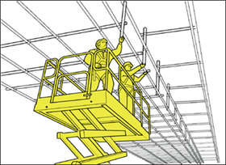](http://www.osh.dol.govt.nz/publications/booklets/scaffolding-09/scaffolding-fig01-large.asp)[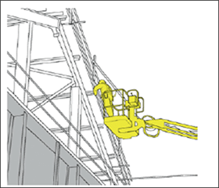](http://www.osh.dol.govt.nz/publications/booklets/scaffolding-09/scaffolding-fig01-large.asp#b)  
Figure 1: Access by EWP

2. Scaffolders can adopt a method of progressively installing a guardrail from the level below before installing the work platform (see figure 2). The scaffolder can then enter the platform with the edge protection already in place. It is acceptable to preinstall a single top rail from below and complete the hand rail and other components from the platform

.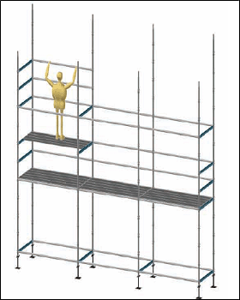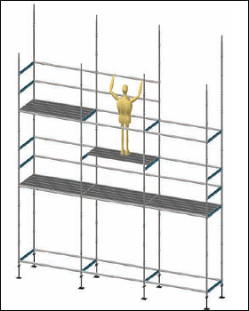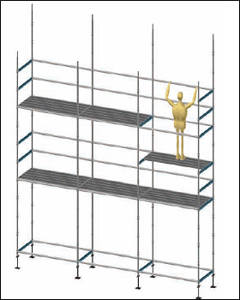  
Figure 2: Progressive guardrail installation method

3. Advance guardrail systems can be used to provide edge protection to scaffold platforms until the scaffolders have installed the permanent guardrail (see figure 3). These systems are designed with uprights or stanchions that attach to the scaffold standards and telescopic rails that allow each stanchion to be moved up to the next platform level while the scaffolder remains within the completed platform below. All platforms guarded by temporary proprietary guardrail systems must be fully planked from below before scaffolders move up to that level to install the platform guardrails.

[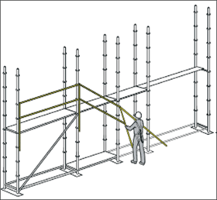](http://www.osh.dol.govt.nz/publications/booklets/scaffolding-09/scaffolding-fig03-large.asp)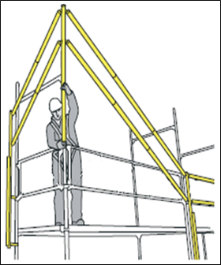  
Figure 3: Advanced guardrail system

#### 2.1.4 Minimising fall hazards

Minimisation of fall hazards must be considered only as a last resort. Minimisation techniques will not eliminate or isolate the hazard, but are designed to protect workers from the harmful effects that could occur. These methods usually have some impact on the mobility and productivity of the scaffolder as well as requiring higher levels of supervision.

Minimisation can include but is not limited to, one or a combination of:

* Training and inductions.
* Ensuring only highly experienced scaffolders undertake the lead build position.
* Working from fully planked platforms.
* Safety nets.
* Fall arrest systems.

Two main approaches to minimising fall hazards are taken in the scaffolding industry. Firstly, the optimum erection and dismantling procedure is employed. This is known as "the tunnelling method" and is outlined below. Secondly, safety harnesses must be worn by all scaffolders when working on all scaffolds above 3.0m high so that fall arrest systems can be accessed (see figure 4).

[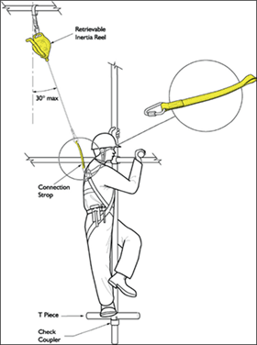](http://www.osh.dol.govt.nz/publications/booklets/scaffolding-09/scaffolding-fig04-large.asp) [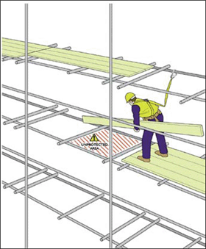](http://www.osh.dol.govt.nz/publications/booklets/scaffolding-09/scaffolding-fig04-large.asp#b)

Figure 4: Scaffolders employing fall arrest systems.

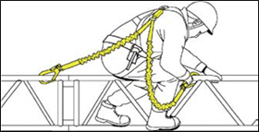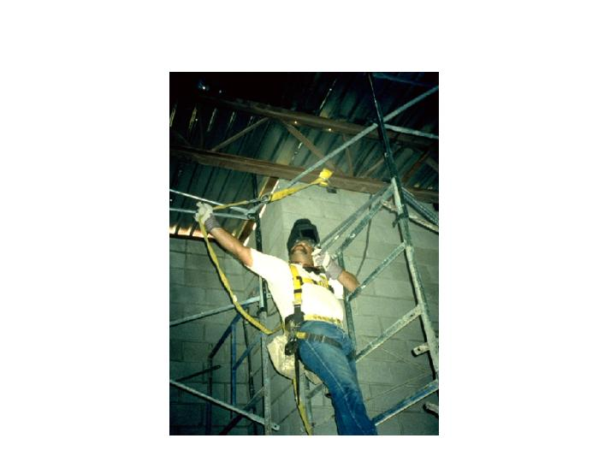

Use 2 lanyard hooking full body safety harness.

### 2.2 Harness systems

Given that fall risk can not always be avoided fall arrest systems must also be employed. Such systems are based around harnesses by which scaffolders are connected to fall arrest devices. With the large selection of belts and harnesses available, it is essential that the correct harness is chosen for the intended use. In particular belts are not suitable for any kind of fall arrest. However, full body harnesses designed for fall arrest may incorporate belts that can be used for work positioning or restraint. Belts that incorporate tool frogs may also be useful and there may be requirements for full body harnesses to accommodate attachments for abseiling, confined space entry, rescue, etc.

When correctly fitted, harnesses should be firm but comfortable. You should be able to slide your hand between the webbing and your body but no more.

#### 2.2.1 When to use anchor points

In all situations other than as described immediately above scaffolders must hook onto the first available anchor point that is at 3.0m or above when:

* Working on an unguarded platform.
* Not working within a 675mm wide planked area.
* Climbing up and down the scaffold structure.
* Working directly off the un-planked scaffold structure.
* Working over a void area.
* Working on a hanging scaffold.
* Working on a cantilever scaffold.

#### 2.2.2 How to use anchor points

Scaffolders should avoid attaching to the scaffold whenever possible. If this is unavoidable you must consider the stability of the scaffold structure with regard to its ability to sustain a fall arrest loading. Safety harnesses should be attached to anchor points on the scaffold above shoulder height. Only if a satisfactory anchor point is not available may it be attached below shoulder height.

Reference : - Safety Manual, SP 44G, SP 46,WIMAINT24,

GN19, GN21

**Amendement Record**

|  |  |  |  |
| --- | --- | --- | --- |
| **Date** | **Manual Section Ref. & Para** | **Brief details of Revision** | **New Rev.** |
|  |  |  |  |
|  |  |  |  |
|  |  |  |  |

|  |  |  |
| --- | --- | --- |
| **Prepared By:**  Head – Mechanical Maintenance | **Reviewed & Issued By:**  Management Representative | **Approved By:**  Head – Central Engineering, Maintenance |
| **Signature:** | **Signature:** | **Signature:** |
| **Review Date: 23.05.2022** | **Review Date: 23.05.2022** | **Review Date: 23.05.2022** |